YES, I LIVE INSIDE A BOX!
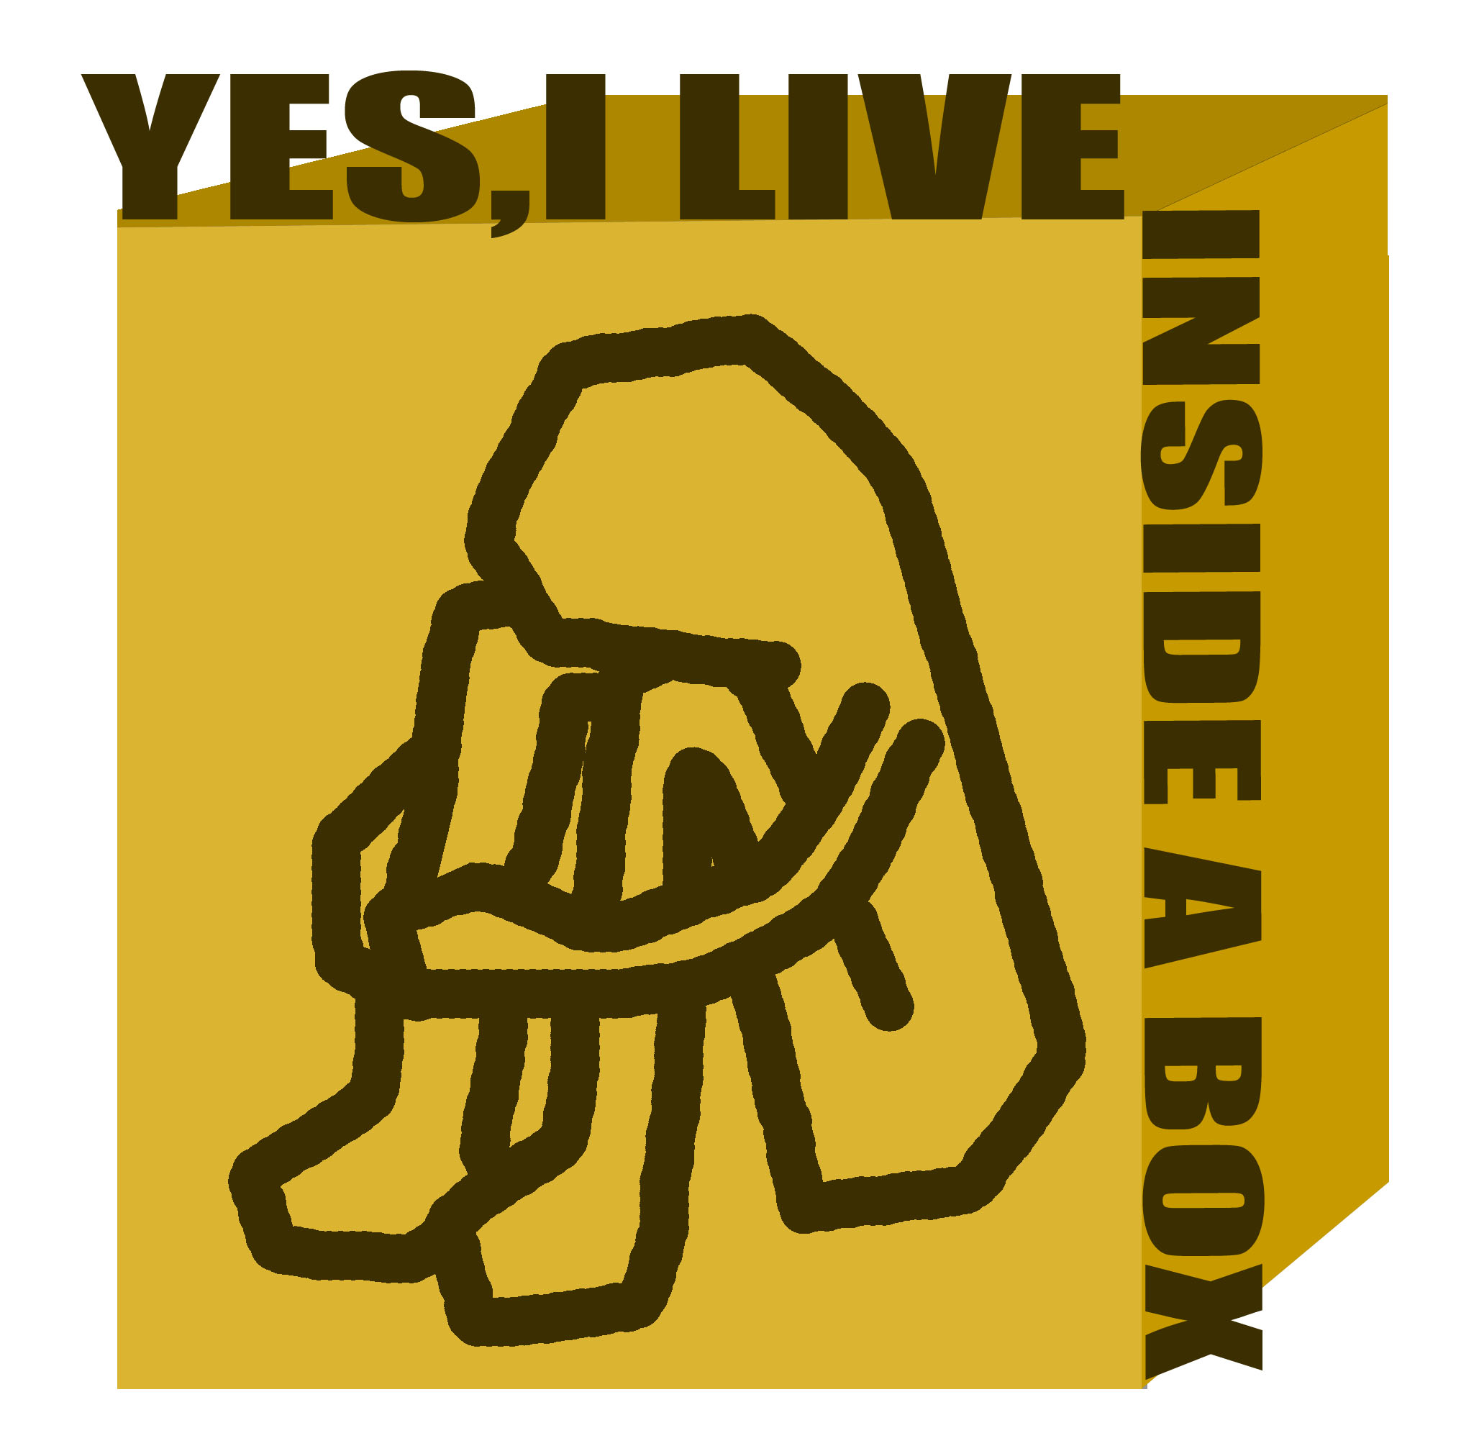
Linoleum emergency houses

FRACTAL INC
Francisco Javier Vaz Cano

Posession never meant anything to me.
I´m not crazy.
Well thats not true.
I´ve got a bed and a guitar.
And a dog named Bob who pisses on my floor.
Thats right I´ve got a floor.So what?
I´ve got pocket full of kleenex.
And lints and holes.
Where everything important to me.
Just seem to fall right down my leg.
And on the floor...
My closest friend linoleum.
Supports my head.
Gives something to believe.

Linoleum NOFX...(music group)

INTRO

My linoleum house gives me something to be alive. Living under the blue sky can be hard sometimes. I´m not trying to create a new trendy and plastic meccano monster full of IKEA stuff. Linoleum houses are not beautifull but they are cheap, ecologic and usefull.

Sleeping in a cold floor can be hard sometimes...

(My twos)THE MOST BEATIFULL HOUSE ON EARTH

It´s my house. The old one was turned into stiches by mother nature. Now I´ve got a new one and that´s cool. Living in a box is not easy but is better than living out there.

You will spend ten minutes working with the frame, ten more with the
walls and a few minutes placing doors,windows and cover. Your family
will be safe and you will feel like the hero of the day.

After use, everything have a new place: metal objects, rubber for sport
tracks or real boxes.

The blue sky turned grey. There were a thousand houses falling down from a plane tied with parachutes.I felt proud of being so important...

THE PACK

A basic house pack contains:

-Metal bars for frame
-Rubber floor
-Linoleum and poliestirene walls
-Plastic door and window
-Plastic cover
-Tool box

(read "how to" page for information)

SO...

It´s easy and cheap and is a new chance for a lot of people. I can´t
start thinking about cool houses if they don´t have a floor under their
feet. I hope you´ll understand...

Thank you very much.

