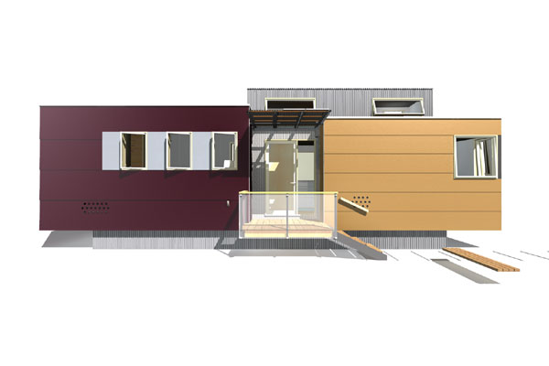
the miniHome – by sustain design studio ltd:

Quite possibly the world's first, completely self-sufficient, ecological trailer design, the miniHome features many of the 'mod-cons' that consumers have come to expect, without the associated energy, resource or material use. Within a well-organized 38 sm (350 sf), there is everything you need for comfortable, year-round, sustainable living. Several climate-specific variants of the miniHome are adapted to the extremes of southern, ocean and even arctic climates and can be further optimized by orientation, glazing and shading options to take full advantage of the 'natural-assets' of each site.

Designed for a 50-year life expectancy, the miniHome offers the possibility for year-round, affordable living on almost any site. It is equally at home in a remote, wilderness setting – completely off-grid – or in an urban trailer park. Its remarkably sustainable combination of energy efficient systems and beautiful finishes usually associated with luxury condominiums results in a home that sings the virtues of simplicity and conservation.

The miniHome will be making it’s debut in April 2006, at the National Home Show in Toronto, Canada. Priced under $100k ($CDN), the miniHome is expected to quickly sell-out the first limited ‘beta’ production run in the summer of 2006.
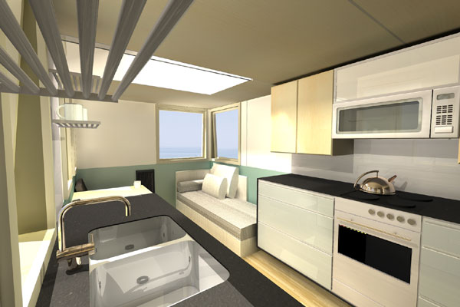

comfortable

- Flooded in daylight by generous windows on the ‘south’ face and the clerestorey loft glazing
- Efficient natural ventilation through convection from the high loft windows and the innovative passive Heat Recovery Ventilator(HRV)
- Full 3-piece bath with luxurious, insulated soaking tub
- Walk-in wardrobe with full-length mirror
- Natural finished woods provide warmth with clean, simple metal and synthetic accents
- Full-size kitchen featuring a gas range and oven, halogen convection microwave, counter-top fridge, and solid surface counters with an under-mount sink
- Standard 110 V electrical outlets, and custom L.E.D. / halogen overhead lighting for warm, even light
- Twelve operable windows for optimal ventilation in any weather
- Constant supply of fresh air through a 30cfm, passive HRV system
- Fast warming radiant panel heating
- Easy access to all systems for maintenance and alterations

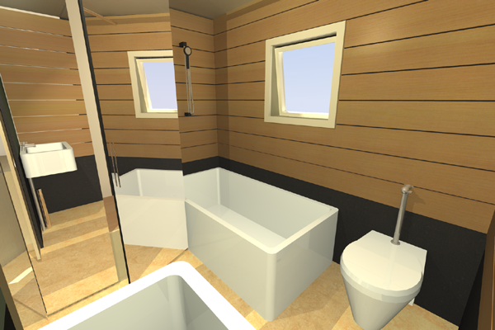
spacious

- open concept, 11m (36’) long floor plan
- double height central space enhances the spacious feeling of the compact design
- Four flexible living zones – bathing, dreaming, cooking, entertaining
- 6.5 sq.m (50 sq.f.) loft for bed, kids playroom, guests or storage
- under-floor storage (and hvac) accessible by flush floor-hatches
- Large closet and 7 overhead storage compartments in the bedroom
- Flip-up dining table and writing desk for flexible use of space
- Modern Davenport bed for a comfortable guest bed with built-in linen storage

affordable

- A fully equipped & furnished home, without any need for site servicing substantially reduces installation costs
- Assembled from proven, available materials and systems drawn from the RV, marine, residential, and commercial construction marketplace
- Designed for efficient factory production (prototyping already underway)
- Extensive use of modular systems such as custom-formed Structurally Insulated Panels (SIPs) providing maximum strength with minimum materials – no waste, ultimately seperable and 100% recycleable
- Several packages of systems available to suit varying budgets and levels of environmental impact.
- High insulation values, with minimal thermal bridging (no condensation nightmares) combine with energy efficient mechanical systems to reduce operating costs to a tiny fraction of those of a regular house (1/100th of typical electrical load, 1/10th of the water and gas consumption)
- Durable materials and construction result in a life span at least double that of conventional trailers and modular housing

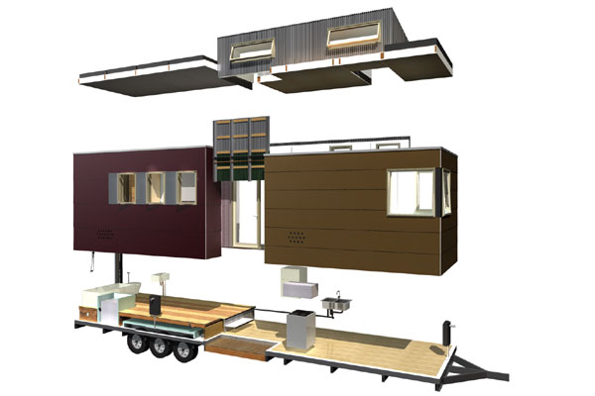
transportable

- Compact dimensions and light-weight design for towing anywhere in North America without the need for special permits or license
- Manufactured to CSA or ANSI standards for trailers
- Full off-grid mechanical systems including wind and solar electrical generation, bio-diesel combined heat and power (CHP), composting toilet, passive HRV, ultra-low load electrical systems, 3-way fridge, and fresh and grey-water holding tanks
- Permanent triple axles and removable hitch make it easy to pick-up and go
- Panelized interior finishes to withstand racking and vibration during transit
- Storage bins and cupboards latch for secure transport
- Solar-panel canopy pivots to vertical position and steps slide off for transit
- Shippable in knock-down condition on a standard heavy equipment flat-deck shipping container for assembly anywhere in the world

green

- Based on 10 years of research in living off-grid, full-time in vehicles, on a shoestring budget
- Exploits the possibilities inherent in the CSA / ANSI codes governing trailers to make an extremely compact, yet versatile lay-out, making living in less than 40 sm extremely comfortable.
- Walls, floors and roof made with Structural Insulated Panels (SIPs)
  - a light-weight rigid structure that eliminates the need for sheathing material – made from staggered, 14ga steel and EPS
  - excellent continuity of insulation, avoiding the thermal bridges common to trailers and manufactured housing
  - precise dimensional control for excellent fit and finish
  - rapid assembly reduces costs
  - eliminates material waste (no on-site cutting required)
  - 100% recyclable
- Natural materials and low-VOC finishes throughout
  - Wheatstock particle board
  - ‘Hevea’ engineered flooring from post-industrial waste
- Solvent-free adhesives, including heavy-duty construction adhesive (Titebond) and finishes to preserve indoor air quality
- Rain-screen pressure-equalized siding system
  - Uses ‘Richlite’, a solid surface counter material made with hemp that has excellent weathering characteristics making it ideal for use as a 6mm ventilated cladding
  - 6mm airspace to provide pressure equalization without sacrificing interior floorspace
- Portable, removable ‘green’ roof
  - Greentech modular bin, Living Roof System, allows easy removal for repairs, pre-season planting, etc.
  - promotes biodiversity
  - buffers rainwater
  - evaporative cooling reduces summer heat gain to allow natural ventilation to maintain a comfortable interior conditions
- Rainwater collection
- 90W Photovoltaic panel on the pivoting awning canopy
- Proprietary 30cfm, passive Heat-Recovery-Ventilator (HRV) with telescoping 'stack-effect-booster' provides energy-efficient source of fresh air
- Zephyr Wind Turbine mounted on the HRV exhaust stack
  - Axial turbines generate 600 Watts of power even in turbulent areas with low elevation and wind speed
- 500ah AGM battery bank – powerful and durable
- Co-generation heating and power system
  - Stirling multi-fuel, MCHP system can burn 100% bio-diesel fuel
  - provides space heating, hot water and electricity all from a single, compact and extraordinarily quiet unit
- Alternate, lower-cost power system for budget applications
  - All propane appliance models (lower cost)
  - Platinum catylitic radiant heaters with integral combustion air intakes
  - Rapid hot-water heater sufficient for a full bath
  - Standard propane cooking and refrigeration
- Biolan Naturum composting toilet eliminates need for sewer connections
- Grey-water storage tank
  - Optional connection to portable biologically based grey-water treatment system

design.

sustain design studio ltd. with Monika Jaroszonek and Rogelio Bayaton.

